Program to an interface, not an implementation: Clients remain unaware of the specific types of objects they use, as long as the objects adhere to the interface that clients expect.
Favor composition over inheritance: Classes should achieve code reusing using composition rather than inheritance from a superclass.
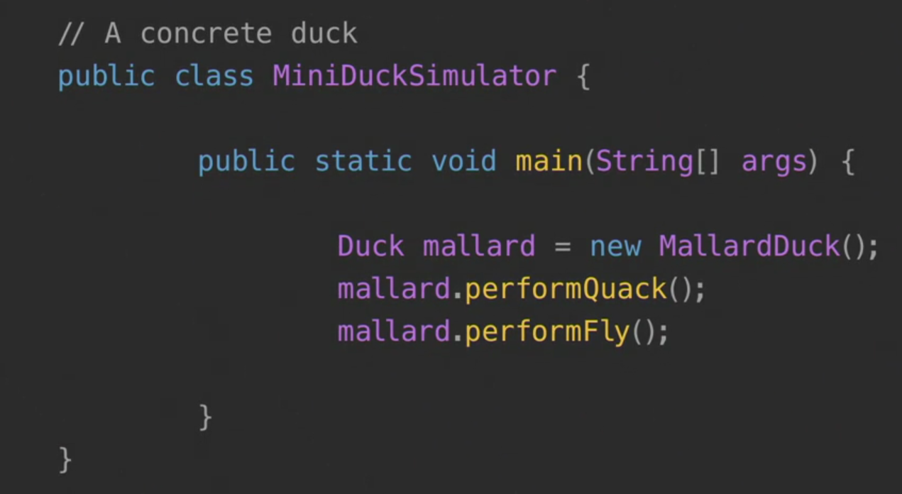
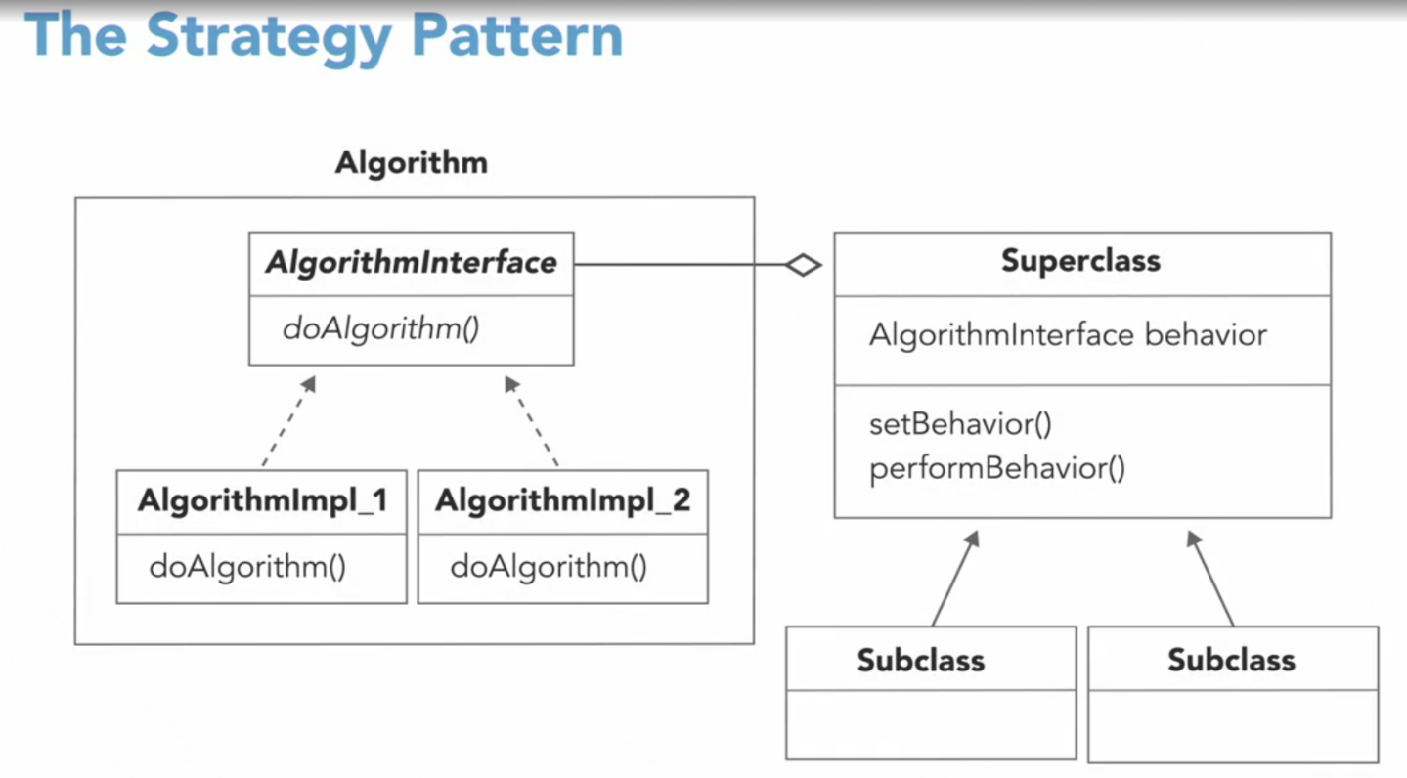
Object oriented design
- Abstraction
- Polymorphism
- Inheritance
- Encapsulation
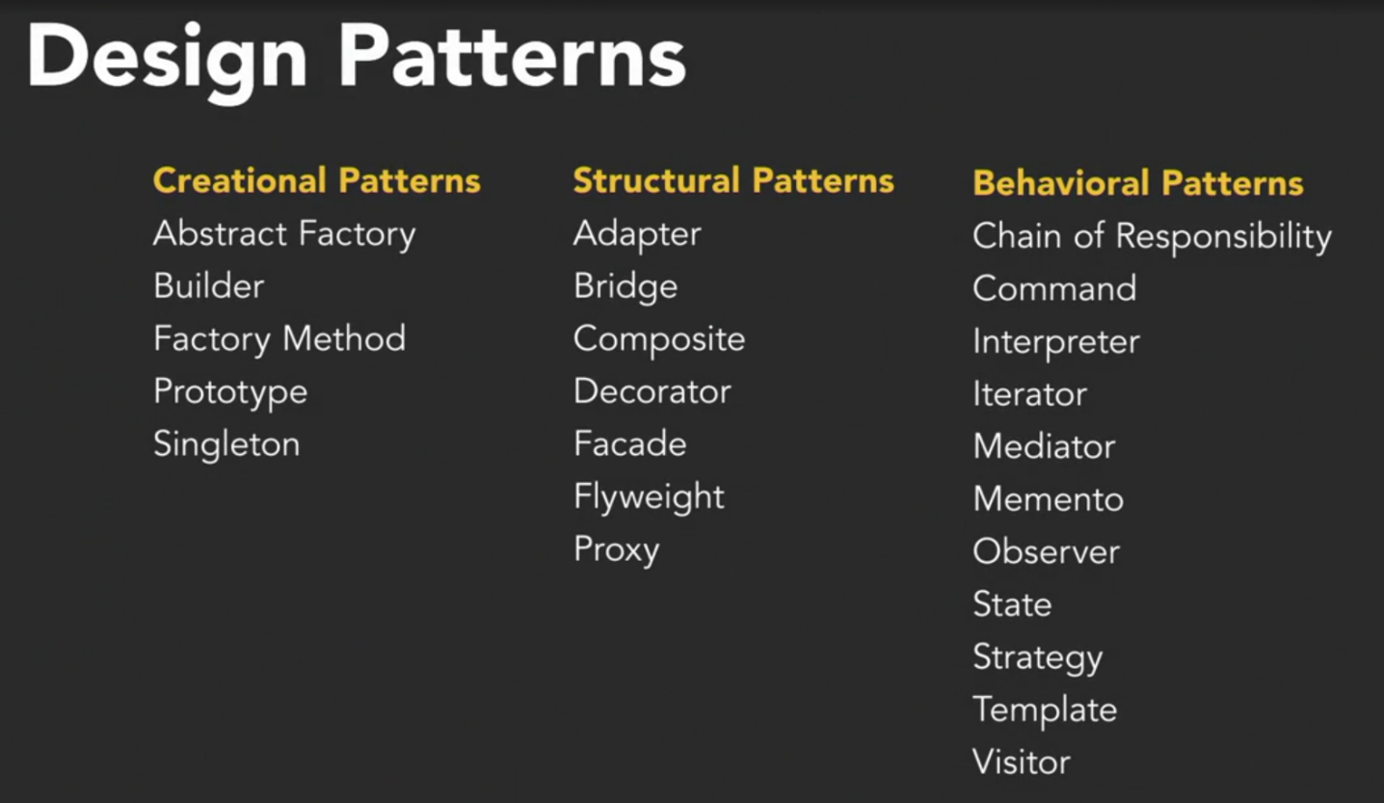
Benefits
- Not reinventing the wheel
- Building resilient code
- Preparing for future additions

The strategy pattern: This pattern defines a family of algorithms, encapsulates each one, and makes them interchangeable.
The focus will be one the following patterns
- Factory method
- Adapter
- Decorator
- Iterator
- Observer
- Strategy
Design principles are general guidelines while design patterns are specific solutions.
Encapsulate what varies: Identify the aspects of your application that vary and separate the from what stays the same.
Interfaces
- An interface defines the methods an object must have to be considered a particular type
- An interface is an abstract type that specifies a behavior that classes must implement
- Interfaces allow different classes to share similarities
- Not all classes need to have the same behavior
Encapsulate what varies
- If some aspect of your code is changing, that’s a sign you should pull it out and separate it
- By separating out the parts of your code that change, you can extend or alter them without affecting the rest of your code
- This principle is fundamental to almost every design pattern

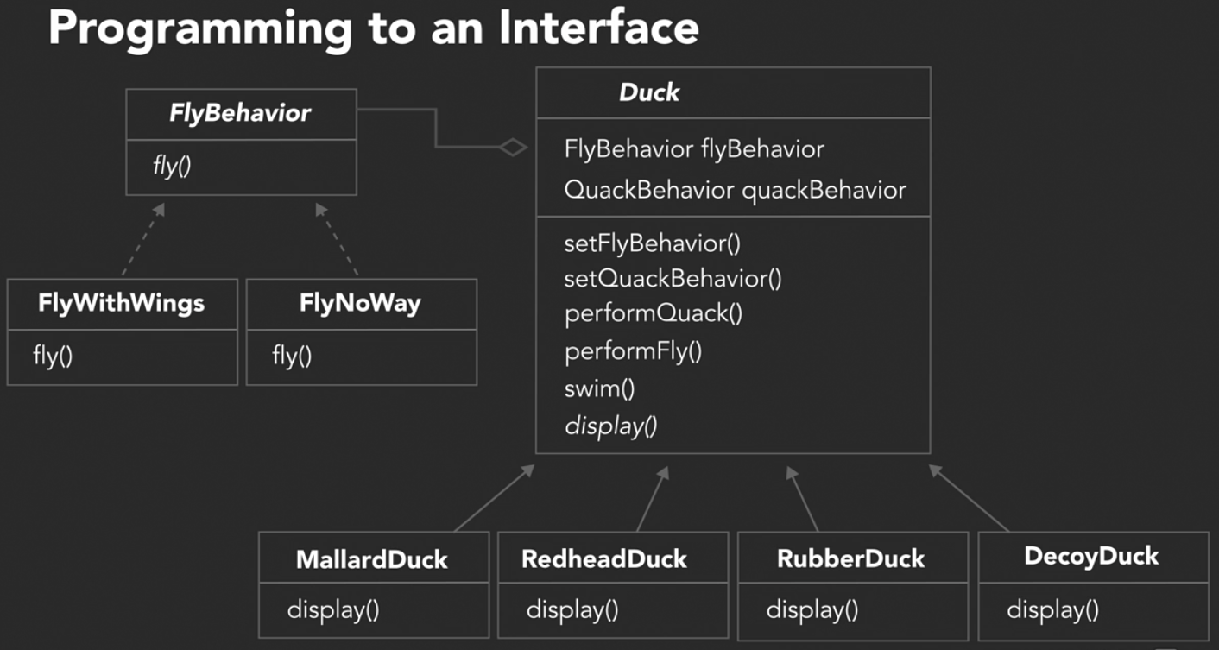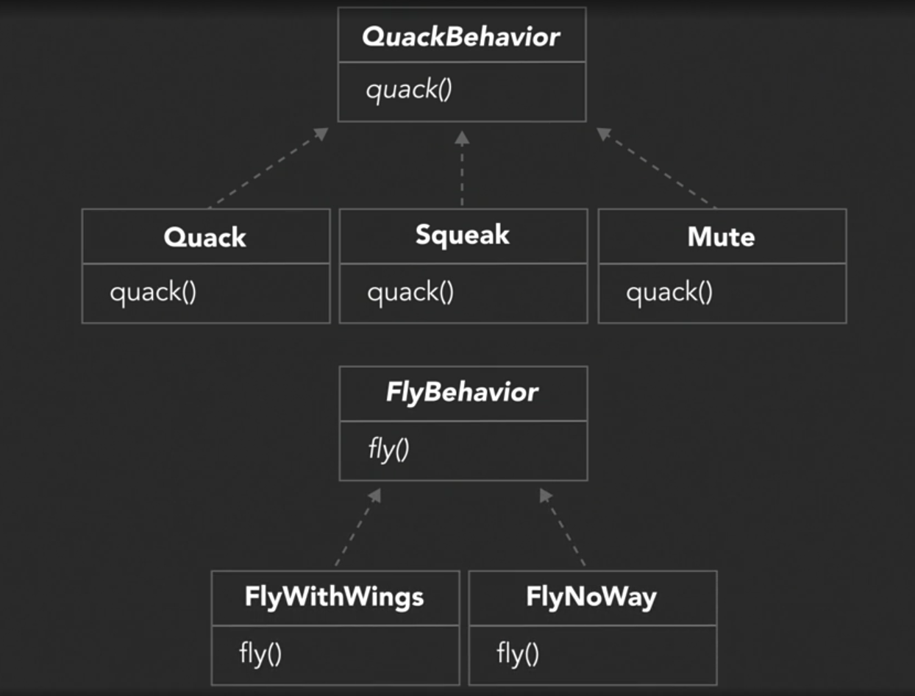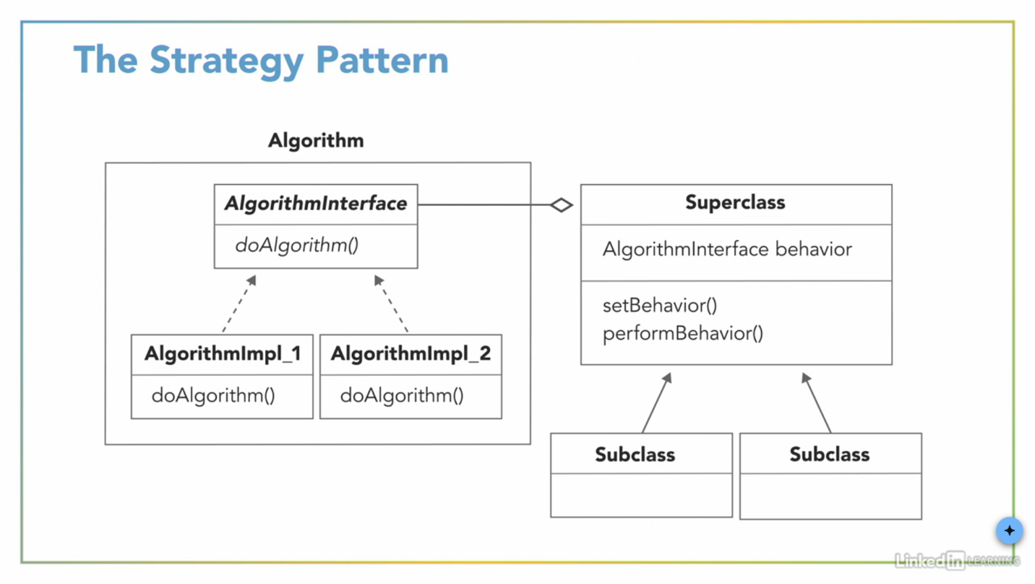
The strategy pattern: This pattern defines a family of algorithms, encapsulates each one, and makes them interchangeable. This lets the algorithm vary independently from clients that use it.
HAS-A is better than IS-A
- We’re using a HAS-A relationship
  - Each duck has a FlyBehavior and a QuackBehavior
- Instead of inheriting behavior, we’re composing it
  - A duck is composed with a fly behavior and a quack behavior
Favor composition over inheritance: Classes should achieve code reuse using composition rather than inheritance from a superclass.

The adapter pattern: This pattern converts the interface of a class into another interface that clients expect. It allows classes to work together that couldn’t otherwise because of incompatible interfaces.
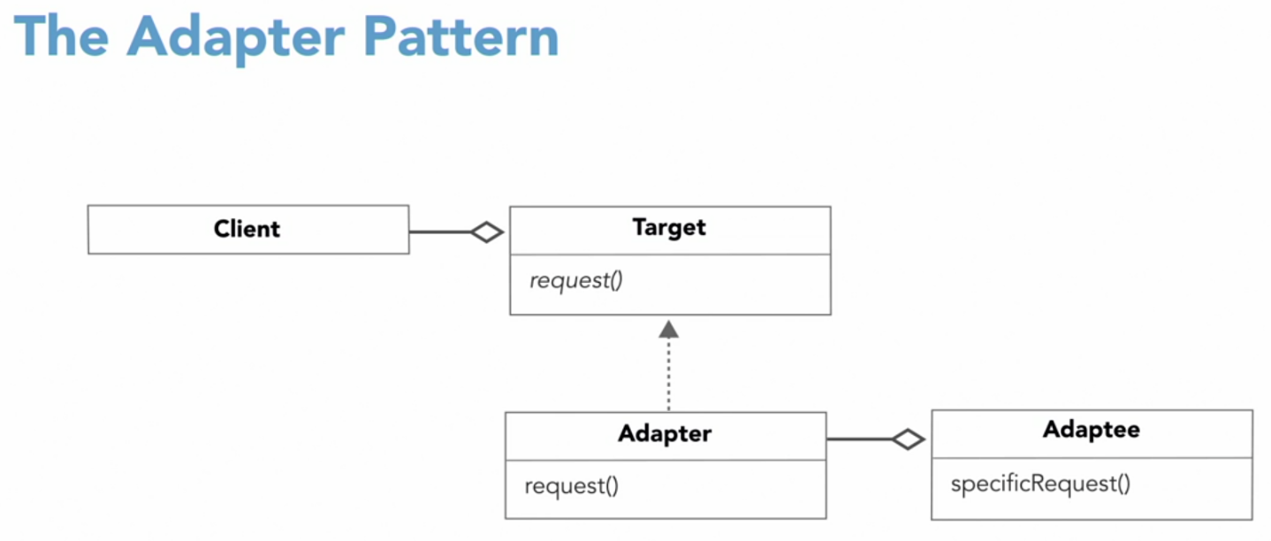
Adapters use composition
- The client is composed with the class with the target interface
- The adapter is composed with the adaptee
- The adapter delegates call to the adaptee, and returns any needed value
- The client and the adaptee don’t know there’s an adapter in between

The observer pattern: This pattern defines a one-to-many dependency between objects so that when one object changes state, all of its dependents are notified and updated automatically.
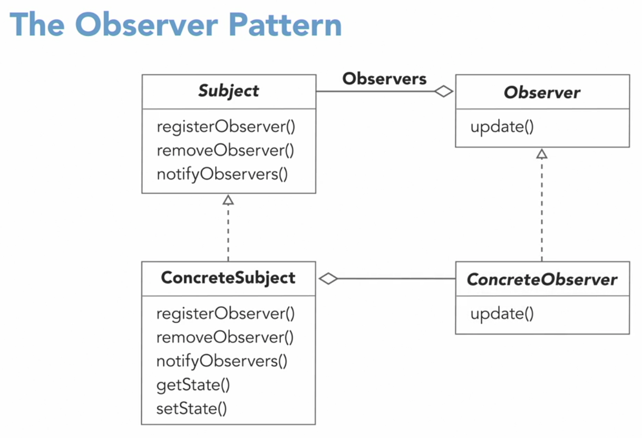
Loose coupling: Strive for loosely coupled designs between objects that interact.
Loose coupling
- Subjects and observes are loosely coupled
- They interact, but have little knowledge of each other
- Subject knows only that the observer implements a specific interface
- Subject doesn’t need to know that concrete class of the observers
- The subject relies on a list of observers
- Observers can be added, removed, or replaced at any time
- Subject doesn’t care; it keeps doing its job
The open-closed principle: Classes should be open for extension but closed for modification.
The open-closed principle
- We want classes to be open for extensions of behavior
- But we also want classes closed to modification
- Our goal is to be able to easily argument what we have without modifying existing code
How do we design object systems that adhere to the open closed principle?
Composition
- We can still “inherit” behavior
- We can make dynamic runtime decisions
- We can add new behavior without altering existing code
- We can include behaviors not considered by the creator

The decorator pattern: This pattern attaches additional responsibilities to an object dynamically. Decorators provide flexible alternative to subclassing for extending functionality.
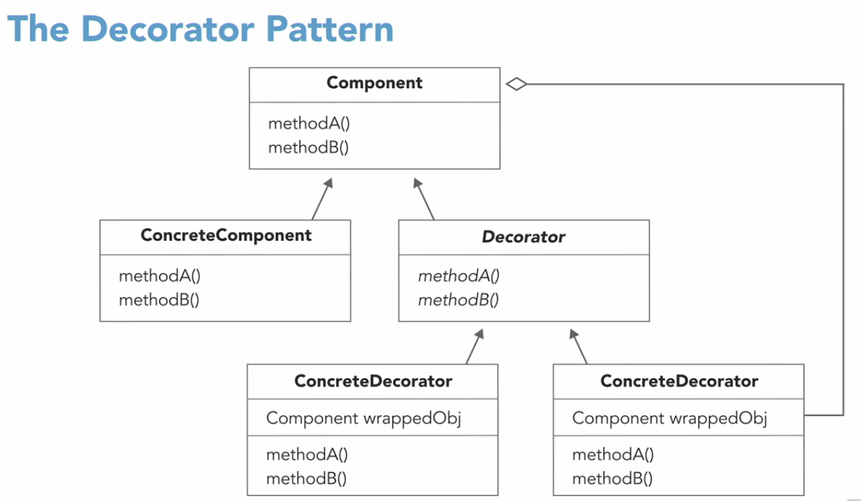

The iterator pattern: This pattern provides a way to access the elements of an aggregate object sequentially without exposing its underlying representation.
Aggregate objects collect objects
- Arrays
- Java collection classes, like ArrayList
- Lists
- Sets
- Maps
- Dictionaries
The factory method pattern: The factory method pattern defines an interface for creating an object, but let’s subclasses decide which class to instantiate. Factory method lets a class defer instantiation to subclasses.
